**Six World Trade Center**

From Wikipedia, the free encyclopedia

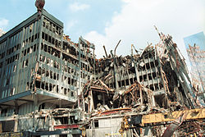

Southwest corner of 6 WTC following September 11, 2001.

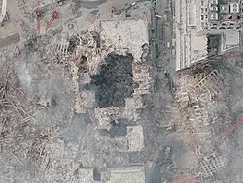

NOAA aerial image following the September 11, 2001 attacks. North is approximately upper right on the image.

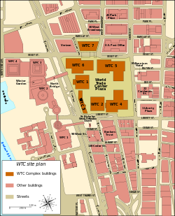

6 WTC, upper left corner.

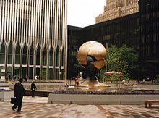

6 World Trade Center behind The Sphere & next to the North Tower, from the Plaza

**Six World Trade Center** was the U.S. Customs House: a 537,693-square-foot (49,953-m²), 8-story building in [Lower Manhattan](http://en.wikipedia.org/wiki/Lower_Manhattan), [New York City](http://en.wikipedia.org/wiki/New_York_City), part of the [World Trade Center](http://en.wikipedia.org/wiki/World_Trade_Center). Construction finished in 1973. It was also the building in the [World Trade Center](http://en.wikipedia.org/wiki/World_Trade_Center) that had the least number of floors. From the [Austin J. Tobin](http://en.wikipedia.org/wiki/Austin_J._Tobin) Plaza level, on which the main structure was built, it had a height of 92 ft (28 m) but was 105 ft (32 m) above actual ground level. It was destroyed on [September 11, 2001](http://en.wikipedia.org/wiki/September_11_attacks).

The building's ruins were demolished to make way for reconstruction. [AMEC](http://en.wikipedia.org/wiki/AMEC) Construction handled the demolition, in which the building was weakened and then pulled down with cables. The new [One World Trade Center](http://en.wikipedia.org/wiki/One_World_Trade_Center) will stand at the site where 6 World Trade Center once stood. There is no clearly defined 6 World Trade Center in the new World Trade Center master plan, although a proposed performing arts center designed by Frank Gehry could be named 6 World Trade Center in the future.

**Tenants**

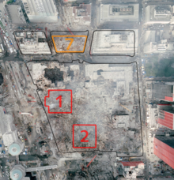

6 WTC, the building with the large, black crater near the northwest corner of the photo.

* [United States Customs Service](http://en.wikipedia.org/wiki/United_States_Customs_Service)
* [United States Department of Commerce](http://en.wikipedia.org/wiki/United_States_Department_of_Commerce)
* [Bureau of Alcohol, Tobacco and Firearms](http://en.wikipedia.org/wiki/Bureau_of_Alcohol,_Tobacco,_Firearms_and_Explosives)
* [United States Department of Agriculture](http://en.wikipedia.org/wiki/United_States_Department_of_Agriculture) - Administrator, Animal and Plant Health Inspection Service (AAPHIS)
* [United States Department of Labor](http://en.wikipedia.org/wiki/United_States_Department_of_Labor)
* The [Peace Corps](http://en.wikipedia.org/wiki/Peace_Corps) (New York Regional Office)
* [Export-Import Bank of the United States](http://en.wikipedia.org/wiki/Export-Import_Bank_of_the_United_States)
* Eastco Building Services (building management)

**See also**

* [7 World Trade Center](http://en.wikipedia.org/wiki/7_World_Trade_Center)
* [5 World Trade Center](http://en.wikipedia.org/wiki/5_World_Trade_Center)
* [4 World Trade Center](http://en.wikipedia.org/wiki/4_World_Trade_Center)
* [Marriott World Trade Center](http://en.wikipedia.org/wiki/Marriott_World_Trade_Center)

This page was last modified on 15 March 2013 at 16:40.